UCL DEPARTMENT OF POLITICAL SCIENCE
SCHOOL OF PUBLIC POLICY

Essay Front Page
Please complete this sheet electronically and attach it as the front page
for each essay submitted.

Candidate Number: WYYR2

Essay Title, Question Number/s or Text of Question/s you have answered:

An Analysis Using the British Social Attitudes Survey 2021

Essay Number: 1

Module Code: POLS0008

Module Title: Introduction to Quantitative Research Methods 25/26

Submission Date: 06/05/2026

Word Count: 2999
The essay cover sheet does not count towards the word count on your submission.
Please tick this box if you do not agree to your essay being used anonymously in future teaching ☐

Introduction
This report analyses public satisfaction with the National Health Service (NHS) using data from the British Social Attitudes (BSA) Survey 2021. The BSA is a nationally representative cross-sectional survey conducted annually in Great Britain, designed to measure the social, political, and moral attitudes of the British public. The 2021 survey includes a module on healthcare and equalities, from which the dataset "bsa2021_healthcare_equalities_open.dta" is drawn. After removing respondents with missing data on any of the variables used in this report, the final sample consists of 6,156 respondents.

The primary outcome variable throughout this report is NHS satisfaction (NHSSatx), measured on an ordinal scale ranging from 1 ("Very satisfied") to 5 ("Very satisfied"). Following the brief, this variable is treated as continuous for Questions 1, 2, and 4, and as a binary/ordinal variable for Question 3. The explanatory variables considered are, total gross household income (HHincomex), which is recorded in six ordered bands, marital status (MarStat6x), with six categories, presence of children in the household (HhlChlGpdx), which is a binary indicator, sex (DVSex21), which is measured in binary male/female, highest educational qualification (hedqual2x), with four ordered categories, and age group (Ragecat), with five ordered categories.

Table 1 presents the sample characteristics for all variables included in the analysis. The sample is broadly balanced by sex, with slightly more female respondents (55.4%). The mode age category is 65+ years (26.4%), and a majority of respondents are married or in a civil partnership (68.8%). Approximately 75.3% of households contain no dependent children. The most common income band is £2,561 - £4,350 per month (25.9%), and a plurality of respondents hold Degree (equivalent & above) as their highest qualification (48.1%). The mean NHS satisfaction score across the full sample is 3.10, and the standard deviation (SD) is 1.15, indicating that the average respondent sits just above "Neither satisfied nor dissatisfied," leaning very slightly toward dissatisfaction, though respondents vary widely in their opinions, with some being very satisfied and others very dissatisfied with the NHS.

Table 1. Complete-case sample characteristics (N = 6156)
Variable / Category | n | %
Sex
Female | 3411 | 55.4
Male | 2708 | 44.0
Age group
18–24 years | 347 | 5.6
25–34 years | 993 | 16.1
35–44 years | 1004 | 16.3
45–54 years | 963 | 15.6
55-59 years | 613 | 10.0
60-64 years | 607 | 9.9
65+ years | 1625 | 26.4
Marital status
Married / civil partnership | 4,235 | 68.8
Divorced / separated | 593 | 9.6
Widowed | 273 | 4.4
Single, never married | 1,055 | 17.1
Children in household
Yes | 1521 | 24.7
No | 4635 | 75.3
Household income
Less than £1,410 per month | 893 | 14.5
£1,411 - £2,560 per month | 1389 | 22.6
£2,561 - £4,350 per month | 1592 | 25.9
£4,351 per month or more | 1390 | 22.6
Highest qualification
Degree (equivalent & above) | 2962 | 48.1
Higher education below degree  (eg. Alevel) | 1696 | 27.6
GCSE / other | 1139 | 18.5
No qualifications | 359 | 5.8
NHS satisfaction (continuous) | Mean = 3.10 | SD = 1.15

Q1. How does satisfaction with the NHS vary within and between the following
categorical measures: household income, marital status and whether there are
children in a household?

To examine variation in NHS satisfaction across categorical sociodemographic groups, means and SDs were calculated for each category of household income, marital status, and the presence of children in the household. The mean is the measure of central tendency of the satisfaction variable, and the SD captures the average amount of variation or dispersion within each group. These are reported in Table 2.

Table 2. Mean NHS satisfaction score by household income, marital status, and children in household
Group | n | Mean | SD
Household Income
Less than £1,410 per month | 447 | 3.03 | 1.20
£1,411 - £2,560 per month | 709 | 3.12 | 1.16
£2,561 - £4,350 per month | 809 | 3.14 | 1.13
£4,351 per month or more | 678 | 3.09 | 1.13
Marital Status
Married / civil partnership | 2103 | 3.11 | 1.14
Divorced / separated | 297 | 3.16 | 1.21
Widowed | 138 | 2.93 | 1.16
Single, never married | 522 | 3.10 | 1.15
Children in Household
Yes | 728 | 3.15 | 1.15
No | 2332 | 3.09 | 1.15

Table 2 presents the mean NHS satisfaction score and SD for each category of household income, marital status, and presence of children in the household. Also, the scale runs from 1 (Very satisfied) to 5 (Very dissatisfied), hence higher scores indicate greater dissatisfaction.

Regarding household income, mean satisfaction scores are similar across income groups, ranging from 3.03 among the lowest income group (less than £1,410 per month) to 3.14 among those earning £2,561–£4,350 per month. There is no clear consistent pattern across income groups, as the middle income band suggests the highest dissatisfaction rather than the highest earners. SDs are similar across all groups, ranges from 1.13 to 1.20, suggesting comparable spread of opinions within each income category.

Regarding marital status, widowed respondents report the lowest mean dissatisfaction score (M = 2.93, SD = 1.16), meaning that they are the most satisfied group. Divorced or separated respondents report the highest dissatisfaction (M = 3.16, SD = 1.21). Married and single respondents are in the middle (M = 3.11 and M = 3.10 respectively). Overall, the differences between groups are small but also suggest widowed respondents view the NHS slightly more favourably than other groups.

Regarding children in the household, respondents with children report slightly higher dissatisfaction (M = 3.15, SD = 1.15) compared to those without children (M = 3.09, SD = 1.15). The difference is very small, and the SDs are identical, hence suggests minimal variation between these two groups.

2. Is there a difference in the mean satisfaction with the NHS by sex?

An independent-samples t-test was used to examine whether mean NHS satisfaction differs between male and female respondents. The null hypothesis is that there is no difference in mean NHS satisfaction between men and women (H0: μmale = μfemale). The alternative hypothesis is that mean satisfaction differs between the two groups (H1: μmale ≠ μfemale). An alpha level of 0.05 is applied throughout.

Four assumptions must be met for the independent-samples t-test. Firstly, the dependent variable must be continuous, as NHS satisfaction is treated as continuous throughout this report. Secondly, the grouping variable must be dichotomous, as sex has two categories (male and female). Thirdly, observations must be independent. Lastly, the data should be approximately normally distributed within each group, which is assessed using a histogram below. Table 3 reports the descriptive statistics and t-test results by sex.

Table 3. Independent-samples t-test of NHS satisfaction by sex
 | n | Mean | SD
Female | 1684 | 3.09 | 1.14
Male | 1361 | 3.11 | 1.16
t-test | degrees of freedom (df) | p-value | 95% CI
-0.50 | 3043 | 0.614 | [-0.10, 0.06]

Table 3 suggests female respondents have a mean satisfaction score of 3.09 (SD = 1.14) and male respondents have a mean of 3.11 (SD = 1.16). Recall that higher scores indicate greater dissatisfaction, so females are more satisfied than males, though the difference is tiny. The independent-samples t-test returned a non-significant result of t(3043)= -0.50, p = 0.614, 95% CI [-0.10, 0.06]. Since p = 0.614 is well above the alpha level of 0.05, we fail to reject the null hypothesis. There is no statistically significant difference in mean NHS satisfaction between male and female respondents. The confidence interval [-0.10, 0.06] crosses zero, which confirms that we cannot rule out that the true difference between the groups is zero.

Figure 1. Distribution of NHS satisfaction scores by sex
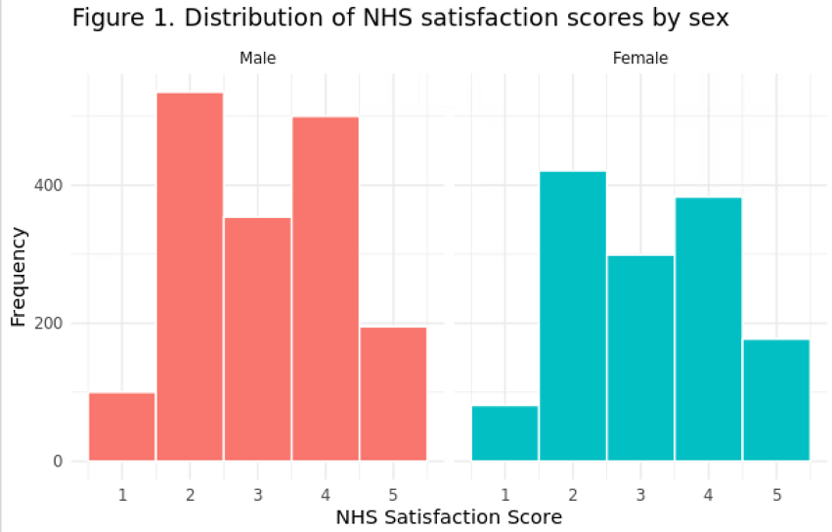

The histograms show that both male and female respondents have a broadly similar distribution across the five satisfaction scores, with no extreme skew in either direction. Given the large sample sizes (female n = 1,684, male n = 1,361), the central limit theorem applies, and the sampling distribution of the mean can be assumed approximately normal, meaning the t-test remains valid.

3. Are people with higher level qualifications more dissatisfied with the NHS?

NHS satisfaction was recoded into a binary variable distinguishing dissatisfied respondents (scores 4–5, indicating quite or very dissatisfied) from those who were not dissatisfied (scores 1–3). A cross-tabulation was produced between this binary satisfaction variable and highest educational qualification, presented in Table 4.

Table 4. Cross-tabulation of NHS satisfaction by highest educational qualification (column percentages)
NHS Satisfaction | Degree or higher | A-level / equiv. | GCSE / equiv. | No qualifications
Dissatisfied (scores 4-5) | 41.03 | 43.17 | 41.26 | 32.93
Not dissatisfied (scores 1-3) | 58.97 | 56.83 | 58.74 | 67.07
Total | 100% | 100% | 100% | 100%

Note. All expected cell frequencies exceed 5. χ²(3) = 5.96, p = 0.113, Cramér's V = 0.044.

Table 4 shows that dissatisfaction rates are broadly similar across qualification groups. Among degree holders, 41.03% are dissatisfied, compared to 43.17% among those with A-level qualifications, 41.26% among those with GCSE qualifications, and 32.93% among those with no qualifications. Those with no qualifications are notably the least dissatisfied group, while A-level holders show the highest dissatisfaction. Overall, there is no clear pattern suggesting that higher qualifications consistently lead to more dissatisfaction.

A chi-square test of independence was used to test whether the association between qualification level and NHS satisfaction is statistically significant. The chi-square test is appropriate here as both variables are categorical and all expected cell frequencies exceed 5. The test returned a non-significant result of χ²(3) = 5.96, p = 0.113. Since p = 0.113 is above the alpha level of 0.05, we fail to reject the null hypothesis. There is no statistically significant association between educational qualification and NHS satisfaction. Cramér's V = 0.044 confirms the association is negligible in size. Therefore, the data do not support the proposition that people with higher qualifications are more dissatisfied with the NHS.

4. Are older people more dissatisfied with the NHS?

Research Hypothesis
Older people will report higher dissatisfaction with the NHS than younger people, in which the older age category will be positively associated with NHS satisfaction scores, where higher scores indicate greater dissatisfaction.

Linear Regression Model
A linear regression model was estimated to examine whether age group predicts NHS satisfaction. Age group was entered as the predictor variable, with 18–24 year olds used as the reference category. The results are reported in Table 5.

Table 5. Linear regression model: NHS satisfaction regressed on age group
Predictor | B  (Coefficient) | SE  (Standard Error) | p-value | 95% CI  (Confidence Interval)
(Intercept / ref: Age 18–24) | 2.93 | 0.09 | < 0.001 | [2.75, 3.10]
Age 25-34 | 0.24 | 0.10 | 0 .020 | [0.04, 0.44]
Age 35-44 | 0.21 | 0.10 | 0 .043 | [0.01, 0.41]
Age 45-54 | 0.32 | 0.10 | 0 .003 | [0.11, 0.52]
Age 55-59 | 0.21 | 0.11 | 0 .062 | [-0.01, 0.43]
Age 60-64 | 0.22 | 0.11 | 0 .048 | [0.00, 0.44]
Age 65+ | 0.04 | 0.10 | 0 .697 | [-0.15, 0.23]
Model fit | R² | Adj. R² | F | p
 | 0.008 | 0.006 | 4.22 | <0.001

Interpretations of Findings
The intercept (B = 2.93, SE = 0.09, p < .001, 95% CI [2.75, 3.10]) represents the estimated mean satisfaction score for the youngest group (18–24 years), which is just below the midpoint of the scale, indicating mild dissatisfaction on average. All age group coefficients are positive, meaning that every older group scores higher, which means more dissatisfied than the youngest group.

Several of these differences are statistically significant at the 0.05 level. The 25–34 group scores 0.24 points higher than the reference group (p = 0.020), the 35–44 group scores 0.21 points higher (p = 0.043), the 45–54 group shows the largest difference at 0.32 points higher (p = 0.003), and the 60–64 group scores 0.22 points higher (p = 0.048). The 55–59 group just misses significance (B = 0.21, p = 0.062). Although, the oldest group, aged 65 and over, shows no significant difference from the youngest group (B = 0.04, p = 0.697). Therefore, the research hypothesis is partially supported. Most middle-aged groups are significantly more dissatisfied than the youngest group, but the oldest group (65+) does not follow this pattern, showing almost no difference from the youngest respondents.

Model Fit
The overall model is statistically significant (F(6, 3038) = 4.22, p < .001), indicating that the age group does significantly predict NHS satisfaction. However, the R² is very low (R² = .008, adjusted R² = .006), meaning that the age group explains only 0.8% of the variance in NHS satisfaction. While the model is statistically significant, it has very poor explanatory power, suggesting that most of the variation in NHS satisfaction is driven by factors not captured by age group alone.

Assumption Checks
Two assumptions of OLS regression residuals were assessed. Firstly, normality of residuals was examined using a Q-Q plot (Figure 3). The Q-Q plot shows some deviation from the diagonal line particularly in the tails, suggesting mild departures from normality. However, given the large sample size the central limit theorem applies, and this is unlikely to seriously bias the estimates.

Secondly, homoscedasticity was assessed using a residuals versus fitted values plot (Figure 4). The plot shows broadly consistent spread of residuals across fitted values with no obvious funnel shape, suggesting the assumption of homoscedasticity is reasonably satisfied.

Figure 3. Normal Q-Q plot of standardised residuals from the regression model

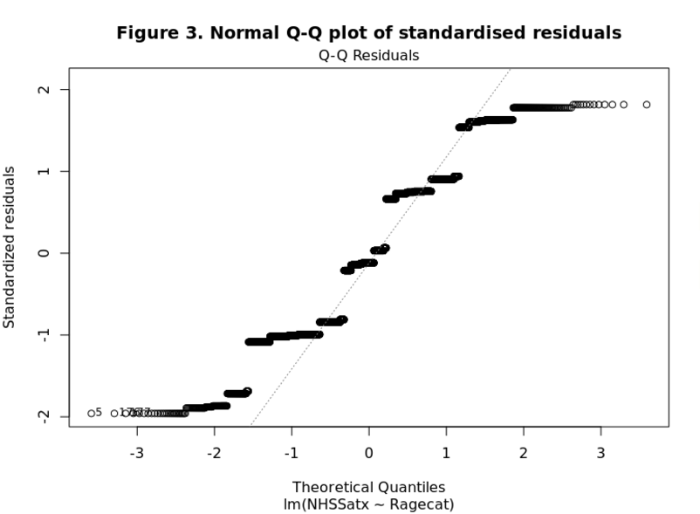

Figure 4. Residuals versus fitted values from the regression model

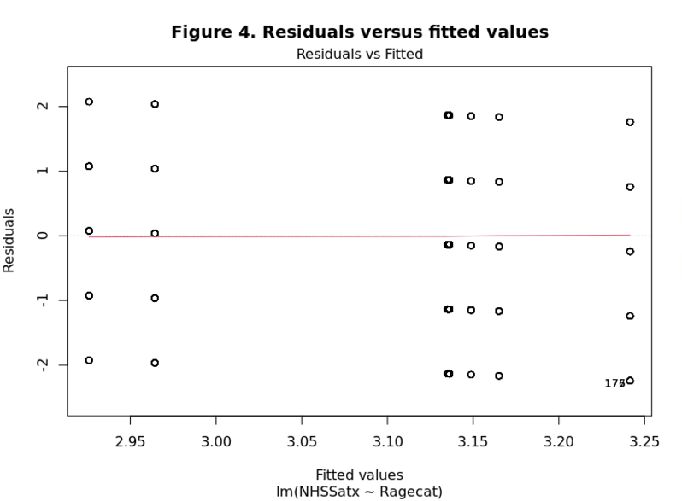

Conclusion
This report examined public satisfaction with the NHS using data from the British Social Attitudes Survey 2021, produces consistent findings across all four analyses, that average NHS satisfaction sits close to the midpoint of the scale (M = 3.10, SD = 1.15), indicating that the average respondent is neither satisfied nor dissatisfied, but marginally leaning toward dissatisfaction. Importantly, the standard deviation indicates considerable variation across the sample, meaning that people feel very differently about the NHS.

Question 1 found that satisfaction varies modestly across household income, marital status, and presence of children. Higher income groups showed slightly higher dissatisfaction, which may reflect greater expectations of public services among those with more resources or greater exposure to private healthcare. Widowed respondents reported the highest satisfaction among marital status groups, while households with children present reported marginally higher dissatisfaction than those without. Overall, the differences between groups were small, suggesting that these sociodemographic factors have limited practical significance in explaining NHS satisfaction.

Question 2 found no statistically significant difference in mean NHS satisfaction between male and female respondents (t(3043) = -0.50, p = 0.614), as the means were almost identical, which is 3.09 for females and 3.11 for males. Also, the confidence interval crossed zero, confirming that sex is not a meaningful predictor of NHS satisfaction in this sample.

Question 3 found no statistically significant association between educational qualification and NHS dissatisfaction (χ²(3) = 5.96, p = 0.113, Cramér's V = 0.044). While degree holders showed slightly higher dissatisfaction rates than those with no qualifications, this pattern was not clear, and the effect size was negligible. The proposition that higher qualification holders are more dissatisfied with the NHS is therefore not supported by this data.

Question 4 found that age group does significantly predict NHS satisfaction overall (F= 4.22, p < .001), with most middle-aged groups reporting significantly higher dissatisfaction than the youngest group. However, the model explains only 0.8% of the variance in satisfaction (R² = .008), indicating very poor explanatory power.

Several limitations apply to these findings. Firstly, the BSA 2021 survey was conducted during the COVID-19 pandemic, which placed unprecedented pressure on the NHS and may have temporarily depressed satisfaction scores, limiting generalisability to normal periods. Secondly, all regression models in this report are deliberately simple and neglected important confounders such as health status. Finally, the cross-sectional design means no causal conclusions can be drawn from any of the relationships observed in this report.

R Script

Load required packages
library(haven)
library(dplyr)
library(ggplot2)

Load data
data <- read_dta("bsa2021_healthcare_equalities_open.dta")

SAMPLE CHARACTERISTICS (Introduction)
Select relevant variables
vars <- c("NHSSatx", "HHincomex", "MarStat6x", "HhlChlGpdx", "DVSex21", "hedqual2x", "Ragecat")
df <- data[, vars]
df <- na.omit(df)

Table 1
nrow(df)
table(df$DVSex21)
table(df$Ragecat)
table(df$MarStat6x)
table(df$HhlChlGpdx)
table(df$HHincomex)
table(df$hedqual2x)
attr(data$DVSex21, "labels")
attr(data$Ragecat, "labels")
attr(data$MarStat6x, "labels")
attr(data$HhlChlGpdx, "labels")
attr(data$HHincomex, "labels")
attr(data$hedqual2x, "labels")
attr(data$NHSSatx, "labels")
df$NHSSatx[df$NHSSatx == -1] <- NA
df$NHSSatx[df$NHSSatx == 8] <- NA
df$NHSSatx[df$NHSSatx == 9] <- NA
mean(df$NHSSatx, na.rm = TRUE)
sd(df$NHSSatx, na.rm = TRUE)

Q1
Mean and SD of NHS satisfaction by household income
df <- na.omit(df)
df %>% group_by(HHincomex) %>% summarise(n = n(), Mean = round(mean(NHSSatx), 2), SD = round(sd(NHSSatx), 2))

Mean and SD of NHS satisfaction by marital status
df$MarStat6x[df$MarStat6x == 8] <- NA
df$MarStat6x[df$MarStat6x == 9] <- NA
df <- na.omit(df)
df %>% group_by(MarStat6x) %>% summarise(n = n(), Mean = round(mean(NHSSatx), 2), SD = round(sd(NHSSatx), 2))

Mean and SD of NHS satisfaction by children in household
df$HhlChlGpdx[df$HhlChlGpdx == 8] <- NA
df$HhlChlGpdx[df$HhlChlGpdx == 9] <- NA
df <- na.omit(df)
df %>% group_by(HhlChlGpdx) %>% summarise(n = n(), Mean = round(mean(NHSSatx), 2), SD = round(sd(NHSSatx), 2))

Q2
Sex
df$DVSex21[df$DVSex21 == 8] <- NA
df$DVSex21[df$DVSex21 == 9] <- NA
df <- na.omit(df)
df %>% group_by(DVSex21) %>% summarise(n = n(), Mean = round(mean(NHSSatx), 2), SD = round(sd(NHSSatx), 2))

Histograms by sex
df$NHSSatx[df$NHSSatx == -1] <- NA
df$NHSSatx[df$NHSSatx == 8] <- NA
df$NHSSatx[df$NHSSatx == 9] <- NA
df$DVSex21[df$DVSex21 == 8] <- NA
df$DVSex21[df$DVSex21 == 9] <- NA
df <- na.omit(df)
ggplot(df, aes(x = NHSSatx, fill = as.factor(DVSex21))) + geom_histogram(binwidth = 1, colour = "white", position = "dodge") + facet_wrap(~DVSex21, labeller = labeller(DVSex21 = c("1" = "Male", "2" = "Female"))) + labs(title = "Figure 1. Distribution of NHS satisfaction scores by sex", x = "NHS Satisfaction Score", y = "Frequency") + theme_minimal() + theme(legend.position = "none")

Independent-samples t-test
(Levene's test was non-significant so equal variances assumed, p > 0.05)
t.test(NHSSatx ~ DVSex21, data = df, var.equal = TRUE)

Cohen's d
install.packages("effsize")
library(effsize)
cohen.d(df$NHSSatx[df$DVSex21 == 1], df$NHSSatx[df$DVSex21 == 2])

Q3
Recode NHS satisfaction, 4-5 = dissatisfied, 1-3 = not dissatisfied
df$sat_binary <- ifelse(df$NHSSatx >= 4, "Dissatisfied", "Not dissatisfied")

Cross-tabulation
ct <- table(df$sat_binary, df$hedqual2x)

Column percentages
prop.table(ct, margin = 2) * 100

Chi-square test
chisq.test(ct)

Cramer's V
library(vcd)
assocstats(ct)

Q4
Age group
df$Ragecat <- as.factor(df$Ragecat)
df$Ragecat <- relevel(df$Ragecat, ref = "1")

Linear regression model
model <- lm(NHSSatx ~ Ragecat, data = df)
summary(model)
confint(model)

Model fit
summary(model)$r.squared
summary(model)$adj.r.squared

Figure 3: Q-Q plot of standardised residuals
plot(model, which = 2,main = "Figure 3. Normal Q-Q plot of standardised residuals")

Figure 4: Residuals vs. Fitted values
plot(model, which = 1,main = "Figure 4. Residuals versus fitted values")

